CATCHEM DESIGN DOCUMENT

Game Designer, Programmer, Artist **Goran Petković**

Game Designer, Tester **Ana Jelušić**

Zagreb, November 2016.

# Story

No story.

# Characters

## Anna the Witch (Halloween edition)

## Anna the Elf (Christmas edition)

# Level/environment design

## Halloween edition

Dark colored. Spooky ambient. Hillside with the house in the background. In foreground bare tree and pumpkins. Full moon in the sky.

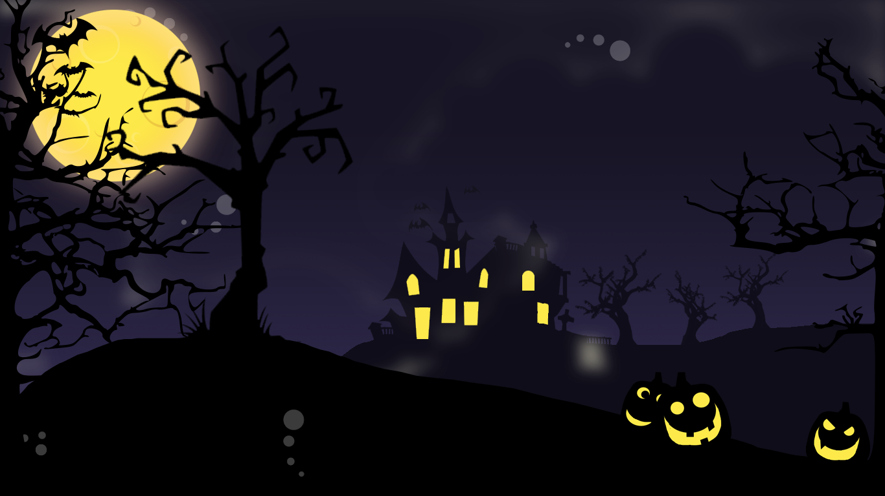

## Christmas edition

Night time. Houses with snowy rooftops. In the foreground evergreen trees and snowman.



## Other

Hillside with sun and trees. Mountains in the background and farming field.

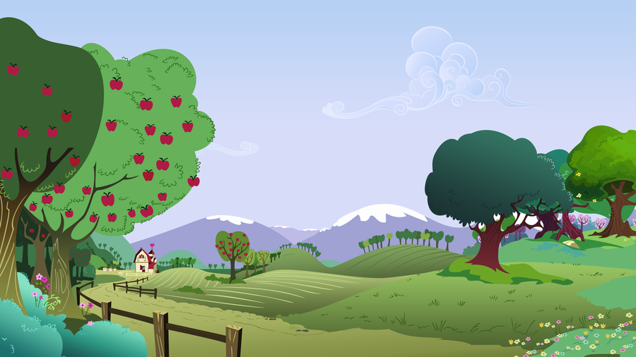

# Gameplay

* Catching falling items. Moving left and right and jumping over items that remains on the floor for few seconds.
* Another mechanic can be clicking on the falling items (mobile specific)

Player can collect basic items that give point depending on various factors. For example, apple that falls in constant slow speed gives less point than faster falling object or objects that are falling in irregular patterns.

Player can collect special items that change game conditions. For example, falling speed of object is slowed (time is slowed), or player can move quickly, or player is invincible for few seconds, or player collects all visible object at that moment that are collectible.

Basic dangerous enemy and item take one life from player. For example, some falling items stay on the ground for few seconds or ghost go through floor level from left to right and vice versa.

# Art

## Main player – Anna

* Anna the Witch (Halloween edition):

Has pointy black had, orange hair and broom in her hand

* Anna the Elf (Christmas edition):

Has elf ears, green and red clothes and pointy shoes.

## Falling items

### Halloween edition

* Red apple
* White Skull
* Pumpkin
* Old clock
* Pointy Hat
* Wizard staff
* Passing Ghost
* Bloody Eye
* Severed Hand

### Christmas edition

* Colorful present
* Candy cane
* Gingerbread smiley
* Santa’s hat
* Spiky holly
* Stockings
* Grinch
* Christmas tree
* Jingle Bells

# Sound and Music

Dark themed music (Halloween edition)

Jolly and jingle bells music (Christmas edition)

Happy tunes

# Game Controls

PC has movement with “a” and “d” buttons and left and right arrows. Also support moving with joypad. Jumping with “space” and “X” button.

# User Interface

Upper left side has heart representing lives. Upper right side has score.

On Android left, right and jump button available in lower side of the screen.